**Rwanda country profile**

Published

17 September 2018

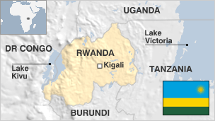

**Rwanda, a small landlocked country in east-central Africa, is trying to recover from the ethnic strife that culminated in government-sponsored genocide in the mid-1990s.**

In the genocide, an estimated 800,000 ethnic Tutsis and moderate Hutus were killed by dominant Hutu forces in 100 days.

The country has struggled with its legacy of ethnic tension associated with the traditionally unequal relationship between the Tutsi minority and the majority Hutus.

Rwanda is striving to rebuild its economy, with coffee and tea production among its main exports. The World Bank has praised Rwanda's "remarkable development successes", which have helped reduce poverty and inequality.

But Paul Kagame, who became president in 2000 and has effectively run Rwanda since 1994, faces criticism at home and abroad over his political and human-rights record.

Read [more country profiles](http://news.bbc.co.uk/1/hi/country_profiles/) - Profiles by [BBC Monitoring](http://www.bbc.co.uk/monitoring)

**President: Paul Kagame**

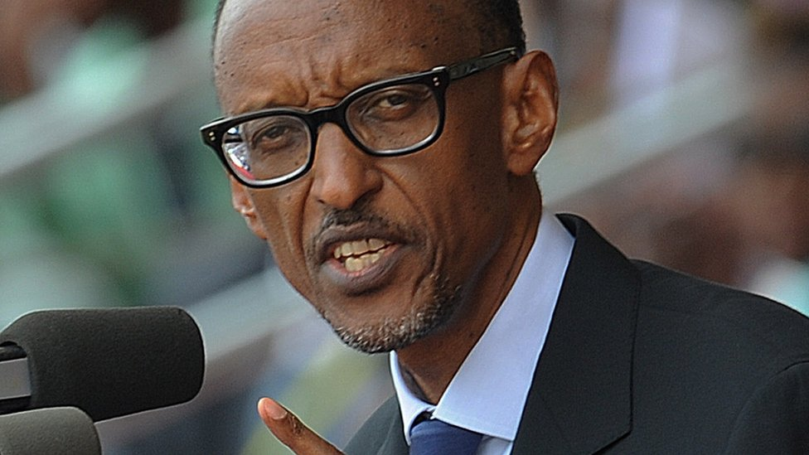image copyrightGetty Images

Paul Kagame has run Rwanda since his rebel army ended the slaughter of hundreds of thousands of people in 1994.

He was sworn in as vice-president and defence minister in the new, post-genocide government in July 1994, but was widely seen as the real power in Rwanda.

In 2000 parliament elected him president. He won presidential elections in 2003 and again in 2010, and gained approval by referendum to stand for an unprecedented third term in 2017 - which he won.

To his admirers he is a visionary leader, but to his critics he is a despot who tolerates no opposition.

Mr Kagame has been criticised for trampling on freedoms, building up the army to assert his authority, and using anti-genocide legislation to clamp down on opponents.

Mr Kagame, born in 1957, left the country as a young child when around half a million fellow Tutsis fled following a bloody Hutu-led uprising. His family settled in Uganda, and Mr Kagame later helped Ugandan President Yoweri Museveni come to power.

From 1990 he led the military arm of the Rwandan Patriotic Army (RPF) in its war against the Hutu-controlled government.

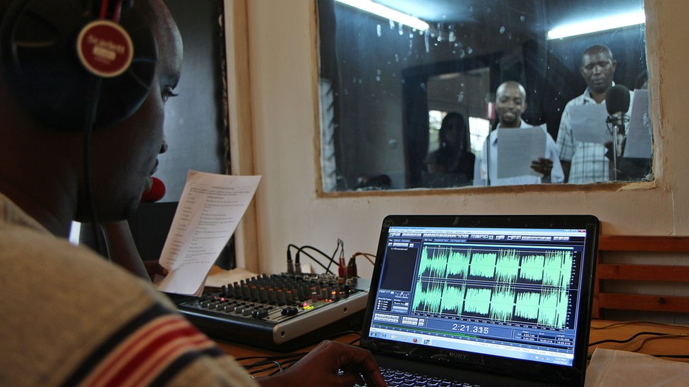image copyrightGetty Images

image captionRadio soap operas have been used to foster peace and reconciliation and to help heal the wounds left by the genocide

State TV and radio reach the largest audiences and operate alongside privately-owned outlets.

Self-censorship is commonplace, says Reporters Without Borders. Exile journalists operate online, prompting website blocking, says Freedom House.

# Rwanda profile - Timeline

Published

17 September 2018

**A chronology of key events:**

**1300s** - Tutsis migrate into what is now Rwanda, which was already inhabited by the Twa and Hutu peoples.

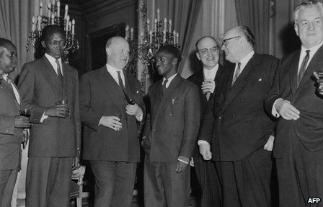image copyrightAFP

image captionHutu Gregoire Kayibanda (c) - seen here with Belgian and Rwandan officials - was independent Rwanda's first president

**1600s** - Tutsi King Ruganzu Ndori subdues central Rwanda and outlying Hutu areas.

**Late 1800s** - Tutsi King Kigeri Rwabugiri establishes a unified state with a centralised military structure.

**1858** - British explorer Hanning Speke is the first European to visit the area.

**1890** - Rwanda becomes part of German East Africa.

**1916** - Belgian forces occupy Rwanda.

**1923** - Belgium granted League of Nations mandate to govern Ruanda-Urundi, which it ruled indirectly through Tutsi kings.

**1946** - Ruanda-Urundi becomes UN trust territory governed by Belgium.

## Independence

**1957** - Hutus issue manifesto calling for a change in Rwanda's power structure to give them a voice commensurate with their numbers; Hutu political parties formed.

**1959** - Tutsi King Kigeri V, together with tens of thousands of Tutsis, forced into exile in Uganda following inter-ethnic violence.

**1961** - Rwanda proclaimed a republic.

**1962** - Rwanda becomes independent with a Hutu, Gregoire Kayibanda, as president; many Tutsis leave the country.

**1963** - About 20,000 Tutsis are killed following an incursion by Tutsi rebels based in Burundi.

**1973** - President Gregoire Kayibanda ousted in military coup led by Juvenal Habyarimana.

**1978** - New constitution ratified; Habyarimana elected president.

**1988** - Some 50,000 Hutu refugees flee to Rwanda from Burundi following ethnic violence there.

**1990** - Forces of the rebel, mainly Tutsi, Rwandan Patriotic Front (RPF) invade Rwanda from Uganda.

**1991** - New multi-party constitution promulgated.

## Genocide

**1993** - President Habyarimana signs a power-sharing agreement with the Tutsis in the Tanzanian town of Arusha, ostensibly signalling the end of civil war; UN mission sent to monitor the peace agreement.

**1994** April - Habyarimana and the Burundian president are killed after their plane is shot down over Kigali; RPF launches a major offensive; extremist Hutu militia and elements of the Rwandan military begin the systematic massacre of Tutsis. Within 100 days around 800,000 Tutsis and moderate Hutus are killed; Hutu militias flee to Zaire, taking with them around 2 million Hutu refugees.

**1994**-**96** - Refugee camps in Zaire fall under the control of the Hutu militias responsible for the genocide in Rwanda.

**1995** - Extremist Hutu militias and Zairean government forces attack local Zairean Banyamulenge Tutsis; Zaire attempts to force refugees back into Rwanda.

**1995** - UN-appointed international tribunal begins charging and sentencing a number of people responsible for the Hutu-Tutsi atrocities.

## Intervention in DR Congo

**1996** - Rwandan troops invade and attack Hutu militia-dominated camps in Zaire in order to drive home the refugees.

**1997** - Rwandan- and Ugandan-backed rebels depose President Mobutu Sese Seko of Zaire; Laurent Kabila becomes president of Zaire, which is renamed the Democratic Republic of Congo.

**1998** - Rwanda switches allegiance to support rebel forces trying to depose Kabila in the wake of the Congolese president's failure to expel extremist Hutu militias.

**2000** March - Rwandan President Pasteur Bizimungu, a Hutu, resigns over differences regarding the composition of a new cabinet and after accusing parliament of targeting Hutu politicians in anti-corruption investigations.

**2000** April - Ministers and members of parliament elect Vice-President Paul Kagame as Rwanda's new president.

**2001** October - Voting to elect members of traditional "gacaca" courts begins. The courts - in which ordinary Rwandans judge their peers - aim to clear the backlog of 1994 genocide cases.

**2001** December - A new flag and national anthem are unveiled to try to promote national unity and reconciliation.

**2002** April - Former president Pasteur Bizimungu is arrested and faces trial on charges of illegal political activity and threats to state security.

**2002** July - Rwanda, DR Congo sign peace deal under which Rwanda will pull troops out of DR Congo and DR Congo will help disarm Rwandan Hutu gunmen blamed for killing Tutsi minority in 1994 genocide.

## DR Congo pull-out

**2002** October - Rwanda says it has pulled the last of its troops out of DR Congo, four years after they went in to support Congolese rebels against the Kabila government.

**2003** May - Voters back a draft constitution which bans the incitement of ethnic hatred.

**2003** August - Paul Kagame wins the first presidential elections since the 1994 genocide.

**2003** October - First multi-party parliamentary elections; President Kagame's Rwandan Patriotic Front wins absolute majority. EU observers say poll was marred by irregularities and fraud.

**2003** December - Three former media directors found guilty of inciting Hutus to kill Tutsis during 1994 genocide and receive lengthy jail sentences.

**2004** March - President Kagame rejects French report which says he ordered 1994 attack on president's plane, which sparked genocide.

**2004** June - Former president, Pasteur Bizimungu, is sentenced to 15 years in jail for embezzlement, inciting violence and associating with criminals.

**2005** March - The main Hutu rebel group, the FDLR, says it is ending its armed struggle. FDLR is one of several groups accused of creating instability in DR Congo; many of its members are accused of taking part in 1994 genocide.

## Mass prisoner release

**2005** July - Government begins the mass release of 36,000 prisoners. Most of them have confessed to involvement in the 1994 genocide. It is the third phase of releases since 2003 - part of an attempt to ease overcrowding.

**2006** January - Rwanda's 12 provinces are replaced by a smaller number of regions with the aim of creating ethnically-diverse administrative areas.

**2006** November - Rwanda breaks off diplomatic ties with France after a French judge issues an international arrest warrant for President Kagame, alleging he was involved in bringing down Habyarimana's plane.

**2006** December - Father Athanase Seromba becomes the first Roman Catholic priest to be convicted for involvement in the 1994 genocide. The International Criminal Tribunal sentences him to life in prison.

**2007** February - Some 8,000 prisoners accused of genocide are released. Some 60,000 suspects have been freed since 2003 to ease prison overcrowding.

**2007** April - Former President Pasteur Bizimungu is released from jail three years into his 15-year sentence after receiving a presidential pardon.

**2007** October - Inquiry launched into 1994 presidential plane crash that sparked the genocide.

**2007** November - Rwanda signs a peace agreement with Democratic Republic of Congo under which the latter will hand over those suspected of involvement in the 1994 genocide to Kigali and to the International Criminal Tribunal for Rwanda.

## Arrests abroad

**2008** January - French police arrest former Rwandan army officer Marcel Bivugabagabo who is on list of war criminals wanted for trial by the Rwandan government.

**2008** February - A Spanish judge issues arrest warrants for 40 Rwandan army officers, accusing them of genocide, terrorism and crimes against humanity.

**2008** August - Rwanda accuses France of having played an active role in the genocide of 1994, and issues a report naming more than 30 senior French officials. France says the claims are unacceptable.

**2008** September - President Paul Kagame's Rwanda Patriotic Front (RPF) wins large majority in parliamentary elections.

**2008** October - Rwanda decides all education will be taught in English instead of French, officially as a result of joining the English-speaking East African Community.

## Genocide trials

**2008** December - One of Rwanda's most famous singers, Simon Bikindi, is sentenced to 15 years in prison for inciting violence during the genocide.

UN report accuses Rwanda and the Democratic Republic of Congo of directly helping Tutsi rebels fighting in eastern DR Congo. Rwanda denies supplying aid and child soldiers.

Theoneste Bagosora sentenced to life imprisonment at UN tribunal for masterminding genocide.

**2009** January - Former Justice Minister Agnes Ntamabyariro is jailed for life by a Kigali court for conspiracy to plan the genocide and speeches inciting people to take part.

**2009** February - Rwandan troops leave the Democratic Republic of Congo five weeks after entering to attack Hutu rebels.

UN war crimes court finds former army chaplain Emmanuel Rukundo guilty of genocide, sexual assault and kidnapping during genocide, sentences him to 25 years in jail.

**2009** March - Rwandan MP and governing party member Beatrice Nirere found guilty of genocide and sentenced to life imprisonment in a traditional gacaca community court.

**2009** November - Rwanda is admitted to the Commonwealth, as only the second country after Mozambique to become a member without a British colonial past or constitutional ties to the UK.

France and Rwanda restore diplomatic relations, three years after they were severed over a row about responsibility for the 1990s genocide.

**2009** December - Rwanda is declared free of landmines - the first country to achieve this status.

**2010** April - Opposition leader Victoire Ingabire, who planned to run against President Kagame in the August elections, is arrested.

**2010** June - Ex-army chief of staff Faustin Kayumba Nyamwasa, a former ally turned critic of President Kagame, is wounded in a shooting while in exile in South Africa.

**Kagame re-elected**

**2010** August - President Kagame wins new term in elections criticised at home and abroad for violence and the disqualification of candidates.

**2011** June - Former family minister Pauline Nyiramasuhuko becomes first woman to be found guilty of genocide by an international court.

**2011** December - Hutu rebel leader Callixte Mbarushimana becomes the first suspect brought to the International Criminal Court (ICC) to be freed after finds rules that there is insufficient evidence for charges of war crimes and crimes against humanity.

**2012** June - Rwanda shuts down "gacaca" community courts that for 10 years tried those accused of involvement in the 1994 genocide.

**2012** July - The US, Britain and the Netherlands halt aid to Rwanda over UN accusations that it is fuelling a rebellion in the Democratic Republic of Congo by training rebel troops. Rwanda denies the charge.

**2012** October - A court sentences opposition leader Victoire Ingabire to eight years in jail on charges of threatening state security and "belittling" the 1994 genocide.

**2012** December - The UN-backed International Criminal Tribunal for Rwanda (ICTR) convicts former government minister and key organiser of the 1994 genocide Augustin Ngirabatware to 35 years in prison.

**2013** February - The ICTR overturns the 2011 genocide convictions of former ministers Justin Mugenzi and Prosper Mugiraneza, to the dismay of Rwandan prosecutors.

**2014** March - Former Rwandan intelligence officer Pascal Simbikangwa is becomes the first man to be convicted in France in connection with the 1994 genocide in Rwanda.

**2015** April - The International Criminal Tribunal for Rwanda holds its last hearings, 10 years after opening, and having convicted 93 individuals in connection with the 1994 genocide.

**2016** January - President Kagame announces that he will stand for the presidency again in 2017, after winning a December referendum on constitutional changes allowing him to serve a third term.

**2017** August - President Kagame re-elected with 98.8% of the vote in polls denounced as unfair by independent observers.

**2018** September - Rwanda pardons more than 2,000 prisoners, including opposition leader Victoire Ingabire, who was jailed in 2012 on charges of threatening state security and "belittling" the 1994 genocide that she says were politically motivated.